**Computer Science & Software Engineering**

**1.2.1B [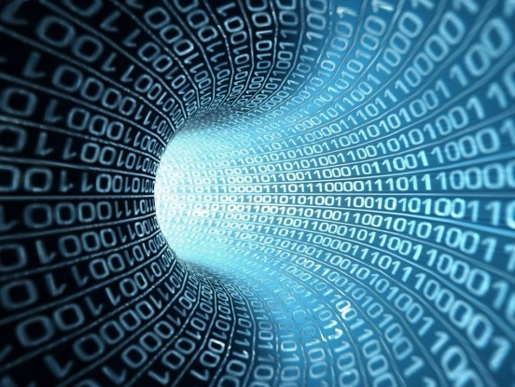](http://www.google.com/url?sa=i&rct=j&q=&esrc=s&frm=1&source=images&cd=&cad=rja&uact=8&ved=0CAcQjRxqFQoTCI6Fifi26scCFY9ckgodozQCzg&url=http://csc.uis.edu/&psig=AFQjCNE59If2l10RKwcmLxqdehT_-gwGTg&ust=1441904172041886)Decimal to Binary Conversion**

Name: __________________

Date: _______ Period _____

Technology Education Dept

Pittsford Central Schools

**Procedure**

To convert a decimal number into a binary number use the divide by 2 method.

Example: convert the decimal number 10 into binary.

10/2=5 remainder 0 LSB

5/2=2 remainder 1

2/2=1 remainder 0

1 /2 = 0 remainder 1 MSB

Binary 10102 = Decimal 1010

OR

128 64 32 16 8 4 2 1 Place value

**Convert the following Decimal numbers to Binary:**

1. 12310 = ___________________

2. 6710 = ___________________

3. 23410 = ___________________

4. 6310 = ___________________

5. 4410 = ___________________

6. 34810 = ___________________

7. 8910 = ___________________

8. 51210 = ___________________

9. 7610 = ___________________

10. 10010 =___________________